

Vocational Training Authority of Sri Lanka

**TUITION CLASS TUTE REGISTRATION SYSTEM**

**Software Requirement Specification**

Software Programming Final Project

Submitted by:

M.K.P.P.Gamyamani

(JL/22/ICT5/1/0007)

Submitted to:

(Supervisor’s signature)

…………………………..

Mr Nishantha Gamage

Date of submission

**2022/08/12**

**Table of Contents**

**Table of Contents ........................................................................................................................ i** **Revision History ......................................................................................................................... . i**

**1.** **Introduction** **1**

1.1 Purpose 1

1.2 Document Conventions 2

1.3 Intended Audience and Reading Suggestions 3

1.4 Product Scope 3

**2.** **Overall Description** **4**

2.1 Product Perspective 4

2.2 Product Functions 4

2.3 User Classes and Characteristics 5

2.4 Operating Environment 6

2.5 Design and Implementation Constraints 6

2.6 Project Documentation 7

2.7 User Documentation 8

2.8 Assumptions and Dependencies 8

**3.** **External Interface Requirements** **9**

3.1 User Interfaces 9

3.2 Hardware Interfaces 13

3.3 Software Interfaces 13

3.4 Communications Interfaces 13

**4.** **System Features** **14**

**5.** **Other Nonfunctional Requirements** **18**

5.1 Performance Requirements 18

5.2 Safety Requirements 18

5.3 Security Requirements 18

5.4 Software Quality Attributes 18

5.5 Business Rules 19

# Revision History

|  |  |  |  |
| --- | --- | --- | --- |
| **Name** | **Date** | **Reason For Changes** | **Version** |
|  |  |  |  |
|  |  |  |  |

# 1. Introduction

## 1.1 Purpose

SRS is the agreement document between the client and the Software developer.

**Feedback to the Customer**-This software requirement specification assures the [project management stakeholders](http://www.my-project-management-expert.com/project-management-stakeholders.html) and client that the developer has really understood the [business requirements documentation](http://www.my-project-management-expert.com/business-requirements-documentation.html) properly. This also provides confidence that the team will develop the functionality which has been detailed.

**Breaking the Requirements Down-**This document is documented in such a way that it breaks the deliverables into smaller components which makes the developer in this project to understand what is to be done clearly.

The information is organized in such a way that the developer (I) can, not only understand the boundaries within which I need to work, but also what functionality needs to be developed and in what order.

Understanding what order the functionality will be developed in means that I, the developer will have the "big picture" view of the development. This gives an opportunity to plan ahead which saves both [project time and cost.](http://www.my-project-management-expert.com/project-time-and-cost.html)

**Facilitating other Documentation-**The SRS forms the basis for a load of other important documents such as the Software Design Specification.

**Product Validation-**It basically helps in validating with the client that the product which is being delivered, meets what they asked for.

Which means that the product I have to output is Equal to the standards of the documentation in the SRS which the client satisfied and agreed on.

**Characteristics of a Software Requirement Specification.**

**1.1.1 Accuracy**

I will ensure the accuracy of the software and the data entered to the database

**1.1.2 Clarity**

This SRS will be clearly state what the user wants in the software.

**1.1.3 Consistency**

The document is consistent from beginning till the end. It helps the readers understand the requirements well.

**1.1.4 Prioritizations of Requirements**

The requirements will be full filled according to the order of priority and preference.

**1.1.7 Verifiability**

At the end of the project, the user/client will be able to verify that all the agreed deliverables have in fact been produced and meet the project management requirements specified.

**1.1.8 Modifiability**

The SRS can be modified when the developer and user feel the need.

**1.1.9 Traceability**

Each requirement stated in the SRS is uniquely associated to a source such as a use case.

## 1.2 Document Conventions

The document is prepared using Microsoft Word 2010 and has used the font type 'Times New Roman'. The fixed font size that has been used to type this document is 12pt with 1.5 line spacing. It has used the bold property to set the headings of the document. All pages except the cover page are numbered; the numbers appear on the lower right hand corner of the page. Every

Image and data table are numbered and referred to the in the main text. Standard IEEE template is the template used to organize the appearance of the document and its flow.

## 1.3 Intended Audience and Reading Suggestions

The intended audience of this document would be the user (the teacher) and project developer, supervisor with the objective to refer and analyse the information. The SRS document can be used in any case regarding the requirements of the project and the solutions that have been taken. The document would final provide a clear idea about the system that is building.

## 1.4 Product Scope

Currently the teacher is using a manual system to handle the tute management process. When a new lesson begins or a lesson finishes, teacher has to keep in mind about the taught tutes. These are being stored in a physical file. Storing, Updating, Inserting and removing the tutes are done manually.

As the current system is a file based one, teacher has to put so much effort on managing the files. They can be easily damaged by fire, insects and natural disasters. Also could be misplaced by losing data and information.

Limited storage space of the files is another issue that they currently face when the

Management is manually done.

If he wants to check a previous tute of a very past unit or other detail, management will be in a great problem. It’s a tough and time taking process to search for a record in a file.

Keeping files takes much time and waste much precious man hours.

The tendency of making mistakes is high when functioning manually. It is more obvious for problems to arise.

I plan to overcome the above mentioned problems through an application, to manage the major functions of the tute registration system.

My goal is to make a client satisfied system by full filling the client requirements and

Improving the current manual system with client needs to improve the standard of the system and of the management of the tutes to its utmost.

The scope of the SRS is basically for everyone involved to understand and have an idea about how and what is going to happen in the system. Using ER, Use Case diagrams, Activity Diagrams and GUI’s which are in a form where everyone can understand how the interfaces finally appear.

# 2. Overall Description

## 2.1 Product Perspective

Our tuition class teachers follow manual procedures to deal with the tute management. That manual system has many issues with regard to efficiency, security, accuracy and reliability. Due to improperly managed details, the tuition classes face quite a lot of difficulties in accessing past data as well as managing present data. The manual file systems which are being used at present require storage facilities .Which is also another overhead?

The fully automated tute management system which will be developed through this project will eliminate the disadvantages caused by the manual system by improving the reliability, efficiency and performance. The usage of a database to store unit id, unit names, tute details will accommodate easy access, retrieval, search and manipulation of data. The system will facilitate concurrent access and convenient management of activities of the tuition class.

## 2.2 Product Functions

#### Tute Management

* Inserting Unit ID, Unit Name and Tute numbers.
* Retrieving the necessary details.
* Deleting the relevant records.
* Provide a user friendly interface.
* Updating the record with relevant changes.

### 2.3 DFD Diagram

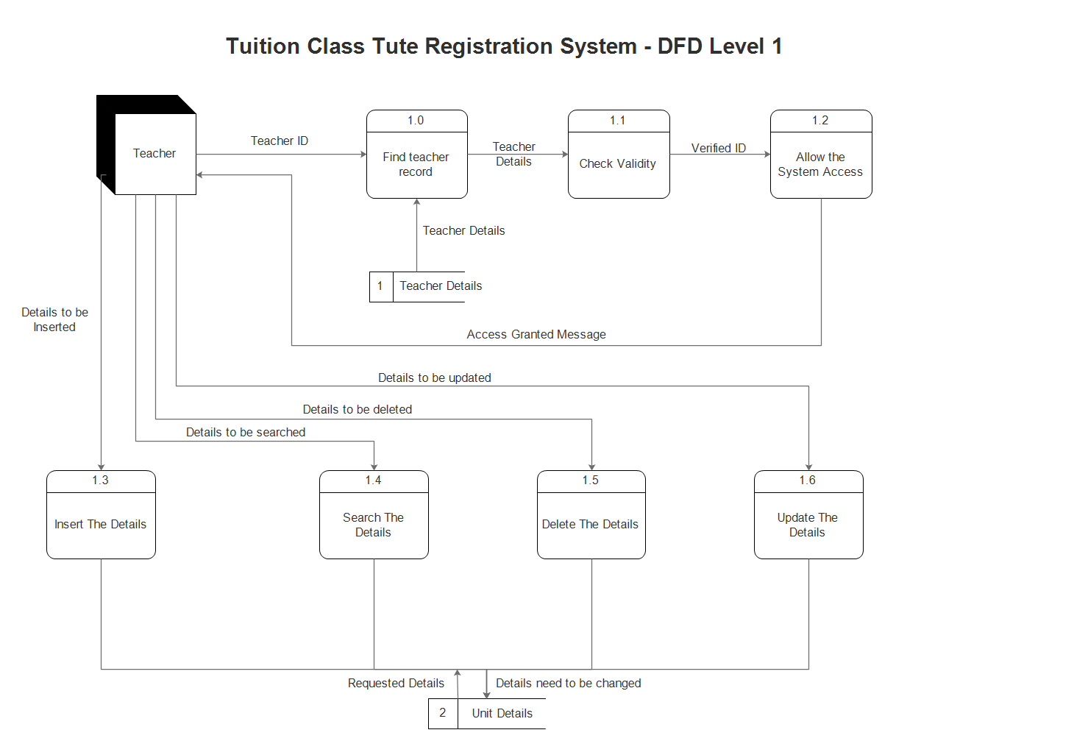

**Figure 2.2 1**

## 

## 2.3 User Classes and Characteristics

* **Teacher**

Interacts with the systems most often to fulfil his activities.

Keyfunctions

* + Keep track of tute details.
  + Insert or Update tute details.
  + Delete tute details.
  + Search for tute details.

## 2.4 Operating Environment

#### Software requirements

* Windows 7 or above operating system
* JRE 1.8
* MySQL server

#### Hardware Requirements

* Core i5 processor
* 4GB Ram
* 20GB of hard disk space in terminal machines
* 1TB hard disk space in Server Machine

## 2.5 Design and Implementation Constraints

* Should use less RAM and processing power.
* Only the teacher can access the whole system.

## 2.6 Project Documentation

|  |  |  |
| --- | --- | --- |
| Software Life Cycle Phase | Documentation | Intended Activities |
| Requirement Gathering,  Analysis and Specification | * Project chart * Project proposal * Software Requirement and Specification (SRS) which includes * Entity relationship diagram * Data flow diagrams * Use case diagrams * Use case scenarios | Includes the customer expected software features, constraints, interfaces and other attributes. Moreover the objectives and the benefits gained through the system are clearly specified. |
| Software Design | ● Software Design  Description(SDD) | Describes the logical basis of design decisions taken and how it will pave way in acquiring the requirements of the customer through the software. |
| Implementation | ● Technical Documentation | Contains information regarding the implementations of the system using the programming concepts. |
| Software Testing | ● Software Test  Documentation (STD) | Includes information degrading testing procedures to validate and verify the software results. Main types of testing techniques are unit testing, integration testing, system testing and acceptance testing. |
| Maintenance | ● User Documentation | Includes manuals for the end users according to their position of access levels. |

## 2.7 User Documentation

As a part of the system itself user documentation is provided to the customers who give an overview of the system. It will include the full description about the product and complete orderly followed steps to install the software. The users will get the opportunity to use the system without having any trouble. The user manual will include the email addresses to contact us in need. Tasks are listed alphabetically or logically grouped often using cross referenced indexes which helps the users to know exactly what sort of information they are looking for.

## 2.8 Assumptions and Dependencies

* Server must be running for the system to function.
* Users must log in to the system to access any record.

# 3. External Interface Requirements

## 3.1 User Interfaces

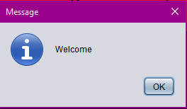

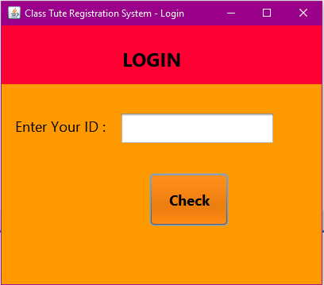

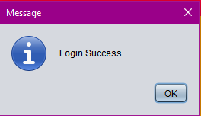

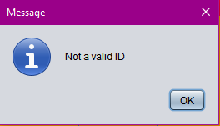

## 

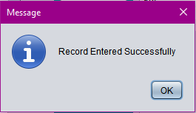

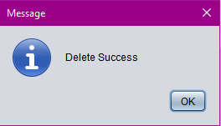

## 

## 

## 3.2 Hardware Interfaces

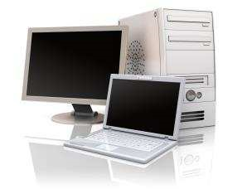

* **Laptop/Desktop PC** 
  + core i5 processor

**Figure 3.2 1**

* + 4GB RAM
  + 500GB HDD

## 3.3 Software Interfaces

**Developing end**

* JDK 1.8 - Java is fast, secure, and reliable.
* Netbeans 8.1 - IDE for Java developing.
* MySQL server - Database connectivity and management

**Client End**

* OS – Windows 7/8/8.1- Very user friendly and common OS
* JRE 1.8 - JAVA Runtime Environment for run Java

Application and System

* MySQL server - Database connectivity

## 3.4 Communications Interfaces

* NIC (Network Interface Card) - Itis a computer hardware component that allows a computer to connect to a network. NICs may be used for both wired and wireless connections.
* CAT 5 network cable- for high signal integrity
* TCP/IP protocol-Internet service provider to access and share information over the Internet
* Ethernet Communications Interface- Ethernet is a frame-based computer network

Technology for local area networks (LANs)

# 4. System Features

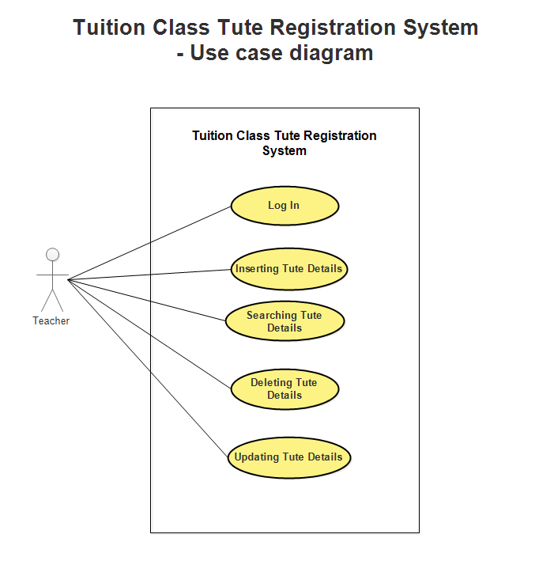**USE CASE Diagram**

**USE CASE Scenarios**

|  |  |
| --- | --- |
| Name | Log In. |
| Description | This function allows the user to log in to the system. |
| Actors | Teacher (user) |
| Pre-conditions | - |
| Main flow of events | 1. User enters his user Id. 2. User clicks check button. 3. System verifies the details. 4. If correct, successfully logged in message displayed and main window displays. 5. If wrong, quit the application. |
| Post conditions | Users logs in to the system. |

|  |  |
| --- | --- |
| Name | Search for Unit Details Entries. |
| Description | This function search and displays details of a unit. |
| Actors | Teacher (user) |
| Pre-conditions | The operator should login with user id. |
| Main flow of events | 1. User selects relevant unit id from the combo box. 2. User clicks search button. 3. If it is a valid unit id, displays the requested information. 4. If it is not valid, error message displays. |
| Post conditions |  |

|  |  |
| --- | --- |
| Name | Add Unit Details Entries. |
| Description | This function gets details of a unit and adds record to the unit details table. |
| Actors | Teacher (user) |
| Pre-conditions | The operator should login with user id. |
| Main flow of events | 1. User selects empty unit id from the combo box. 2. User enters data to required fields. 3. User clicks insert button. 4. Successfully record added message displayed. |
| Post conditions | Unit records added to unit file. |

|  |  |
| --- | --- |
| Name | Delete Unit Details Entries. |
| Description | This function deletes details of a unit and clears the record from the unit details table. |
| Actors | Teacher (user) |
| Pre-conditions | The operator should login with user id. |
| Main flow of events | 1. User selects relevant unit id from the combo box. 2. User clicks delete button. 3. Successfully record deleted message displayed. |
| Post conditions | Unit records deletes from a file. |

|  |  |
| --- | --- |
| Name | Update Unit Details Entries. |
| Description | This function update the details of a unit and also updates the unit table with the new data. |
| Actors | Teacher (user) |
| Pre-conditions | The operator should login with user id. |
| Main flow of events | 1. User selects relevant unit id from the combo box. 2. User enters data to required fields. 3. User clicks update button. 4. Successfully record updated message displayed. |
| Post conditions | Unit records updates in the unit file. |

**ER Diagram**

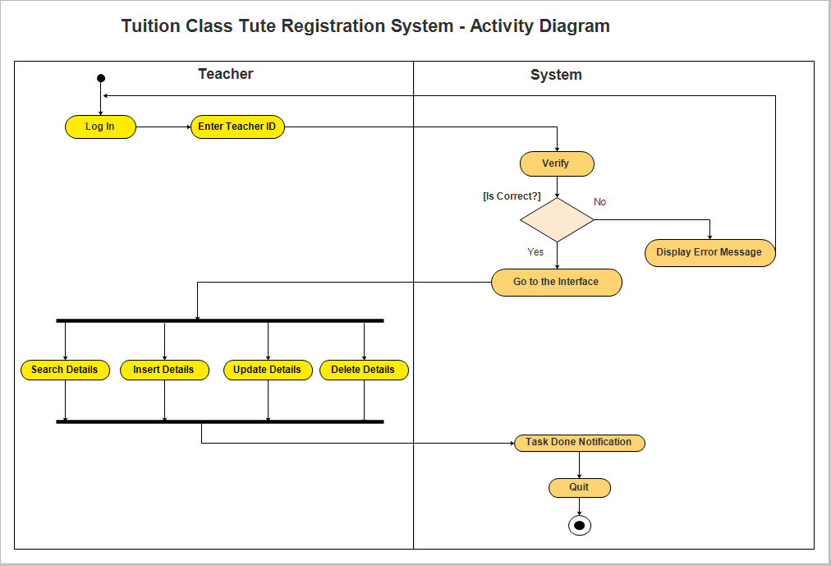

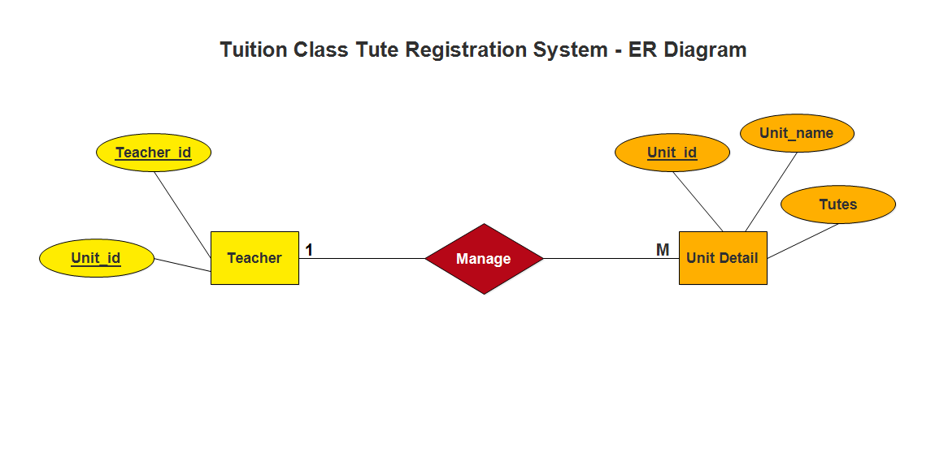

**Activity Diagram**

# Other Non-functional Requirements

## 5.1 Performance Requirements

* Response time-The system will give responses within 1 second.
* User interface- User interface screen will response within 5 seconds.
* Conformity –The system must conform to the Microsoft accessibility.

## 5.2 Safety Requirements

If there is extensive damage to a wide portion of the database due to catastrophic failure, such as a disk crash, the recovery method restores a past copy of the database that was backed up to archival storage and reconstructs a more current state by reapplying or redoing the operations of committed transactions from the backed up log, up to the time of failure. System must be installed with original version of Windows OS with perfect license to avoid duplication problems.

## 5.3 Security Requirements

There will be proper security mainly regarding data accessibility. Security to user can be provided by login authentication. Data stored in database should be private. All the administrative and data entry operators have unique logins so system can understand who is login in to system right now and no intruders allowed.

## 5.4 Software Quality Attributes

The additional quality characteristics are important both for the user and for the developer. Some of the attributes of this system are as follows:

* AVAILABILITY: The system shall be available all the time.
* CORRECTNESS: A bug free software which fulfil the correct need/requirements of the

Client.

* MAINTAINABILITY: The ability to maintain ,modify information and update fix problems of the system
* USABILITY: software can be used again and again without distortion.
* ACCESSIBILITY: Administrator and many other users can access the system but the access level is controlled for each user according to their work scope.
* ACCURACY: The reliability on the information/output. Can depend/be sure of the outcome.
* STABILITY: The system outcome/output won’t change time to time. Same output will be given always for a given input.
* PORTABILITY: The system developed as a whole should be of very small size. So that it is easily portable with the help of hand-held device.

## 5.5 Business Rules

* Want take the responsibility of failures due to hardware malfunctioning.
* Warranty period of maintaining the software would be one year.
* Additional payments will be analysed and charged for further maintenance.
* If any error occur due to a user’s improper use. Warranty will not be allocated to it.
* No money back returns for the software.